**Dennis Tikhomirov. DevOps Spring’19.**

**Homework Task #4 (Vagrant).**

**1. Vagrant vs VirtualBox**

**1.1. Install VirtualBox**

**1.2. Install Vagrant**

**1.3. Create a Vagrantfile based on the box Windows 10**

**1.3.1. Install Windows 10 with network settings**

Vagrantfile

Vagrant.configure("2") do |config|`

config.vm.box = "senglin/win-10-enterprise-vs2015community"

config.vm.box_version = "1.0.0"

config.vm.network "public_network"

config.vm.provider "virtualbox" do |vb|

vb.gui = true

vb.memory = "1024"

end

end

Commands

vagrant init senglin/win-10-enterprise-vs2015community \ --box-version 1.0.0

vagrant up

Screenshot #1. Installed Win10 on VirtualBox

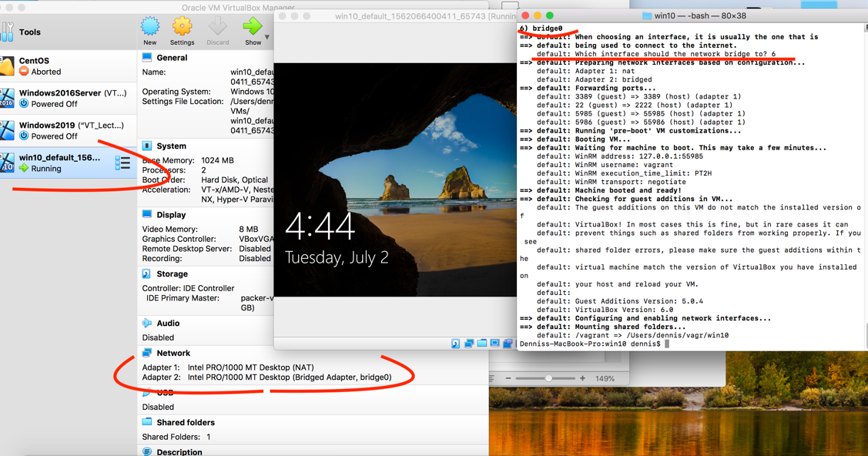

Notice:

Downloading too slow !!!! <https://github.com/hashicorp/vagrant/issues/8434>

*Faster way to install package it is straight download from source (url is shown in loading process ) and next to install it:*

1. *In Vagrantfile specify relative path to package.box file:*

config.vm.box_url = “$relativePath/package.box"

1. *Run command*

Vagrant up

**1.3.2. Connect to the box via vagrant ssh**

vagrant status // show VMs

vagrant ssh default // connect to VM [default]

-sh-4.1$ systeminfo // Windows command

Screenshot #2. Connect to VirtualBox VM trough Vagrant

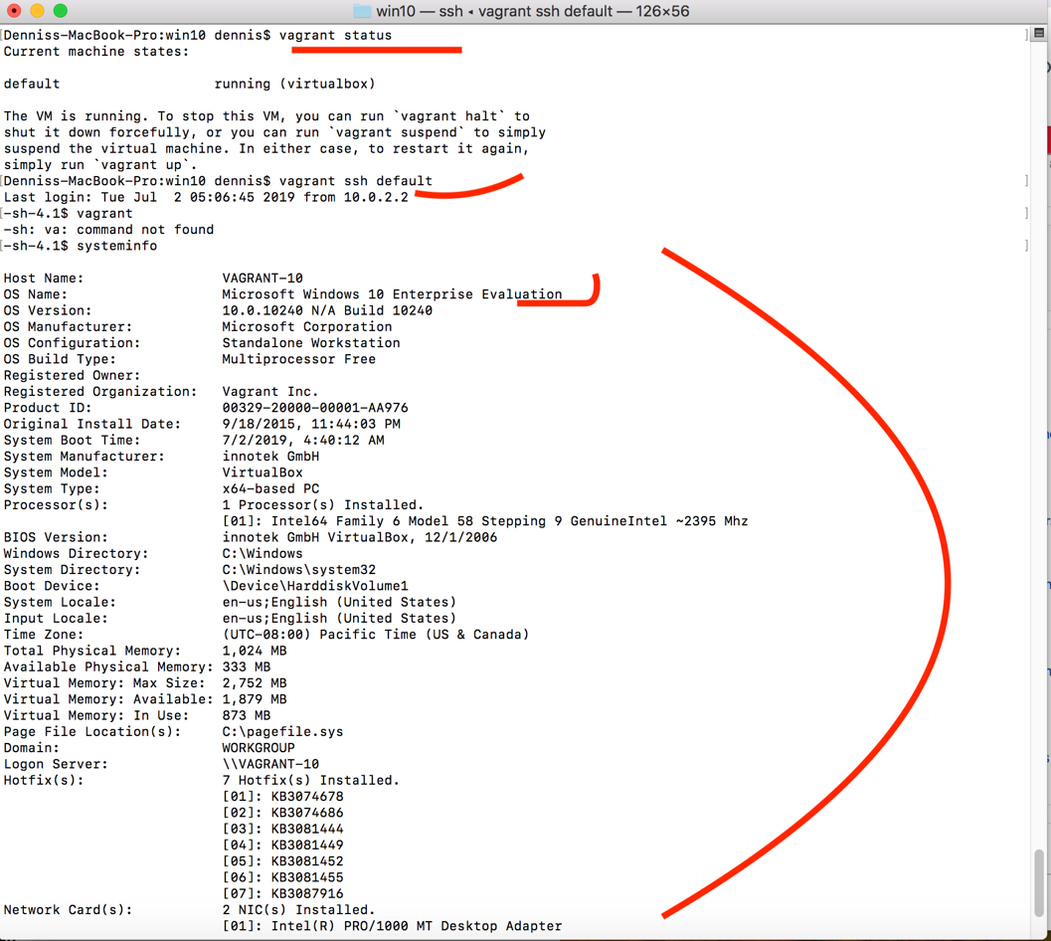

**1.3.3. Remove box**

vagrant halt default // gracefully stop VM (or --force)

vagrant destroy default //remove VM.

**1.4. Create a multi-box configuration with a local network, using for three client VM boxes with Ubuntu 1804 and for a server – VM box with Windows 10**

**1.4.1. Using provisioning install MySQL Server in Windows OS and configure guest connection to MySQL Server using different usernames for client machines**

**msiexec /i mysql-installer-web-community-8.0.16.0.msi /passive**

**1.4.2. Using provisioning install MySQL Client in all Ubuntu OS and set up connections**

**1.4.3. Up all boxes with one command and connect via vagrant ssh to all boxes and check the connection of clients to the MySQL Server**

I used Ubuntu18.04 instead Windows10 as a MySQL server

Vagrant file

Vagrant.configure("2") do |config|

#MYSQL SERVER

config.vm.define "SServerMySQL" do |server|

config.vm.provider "virtualbox" do |vb|

vb.memory = "1024"

end

server.vm.box = "geerlingguy/ubuntu1804"

server.vm.network "private_network", ip: "192.168.50.10"

server.vm.provision "shell", inline:<<-SHELL

DIR=/etc/mysql/

IP=192.168.50

sudo ufw allow from any to any port 3306 proto tcp

sudo apt-get update

sudo apt-get install --reinstall iptables

sudo apt-get install net-tools

sudo apt-get install -y mysql-server

sudo touch $DIR/init.sql

sudo chmod 777 $DIRinit.sql

sudo echo "CREATE USER user IDENTIFIED BY 'pass';">>$DIR/init.sql

sudo echo "CREATE USER user1@${IP}.10 IDENTIFIED BY 'pass1';">>$DIR/init.sql

sudo echo "CREATE USER user2@${IP}.2 IDENTIFIED BY 'pass2';">>$DIR/init.sql

sudo echo "CREATE USER user3@${IP}.3 IDENTIFIED BY 'pass3';">>$DIR/init.sql

sudo echo "CREATE USER user4@${IP}.4 IDENTIFIED BY 'pass4';">>$DIR/init.sql

sudo cat $DIR/init.sql

sudo echo "[mysqld]" >$DIR/my.cnf

sudo echo "init-file=/etc/mysql/init.sql" >>$DIR/my.cnf

sudo echo "bind-address = 0.0.0.0" >>$DIR/my.cnf

sudo chmod 444 $DIR/my.cnf

sudo cat $DIR/my.cnf

sudo /etc/init.d/mysql restart

SHELL

End

# MYSQL CLIENTS

(1..3).each do |i|

config.vm.define "CClient#{i}" do |ubuntu|

config.vm.provider "virtualbox" do |vb|

vb.memory = "1024"

end

ubuntu.vm.box = "geerlingguy/ubuntu1804"

ubuntu.vm.network "private_network", ip: "192.168.50.#{i+1}"

ubuntu.vm.provision "shell", inline:<<-SHELL

sudo apt-get update

sudo apt-get install net-tools

sudo apt-get install -y mysql-client-core-5.7

SHELL

end

end

end

Screenshot #3. MySQL server and three Ubunru VMs are logged in

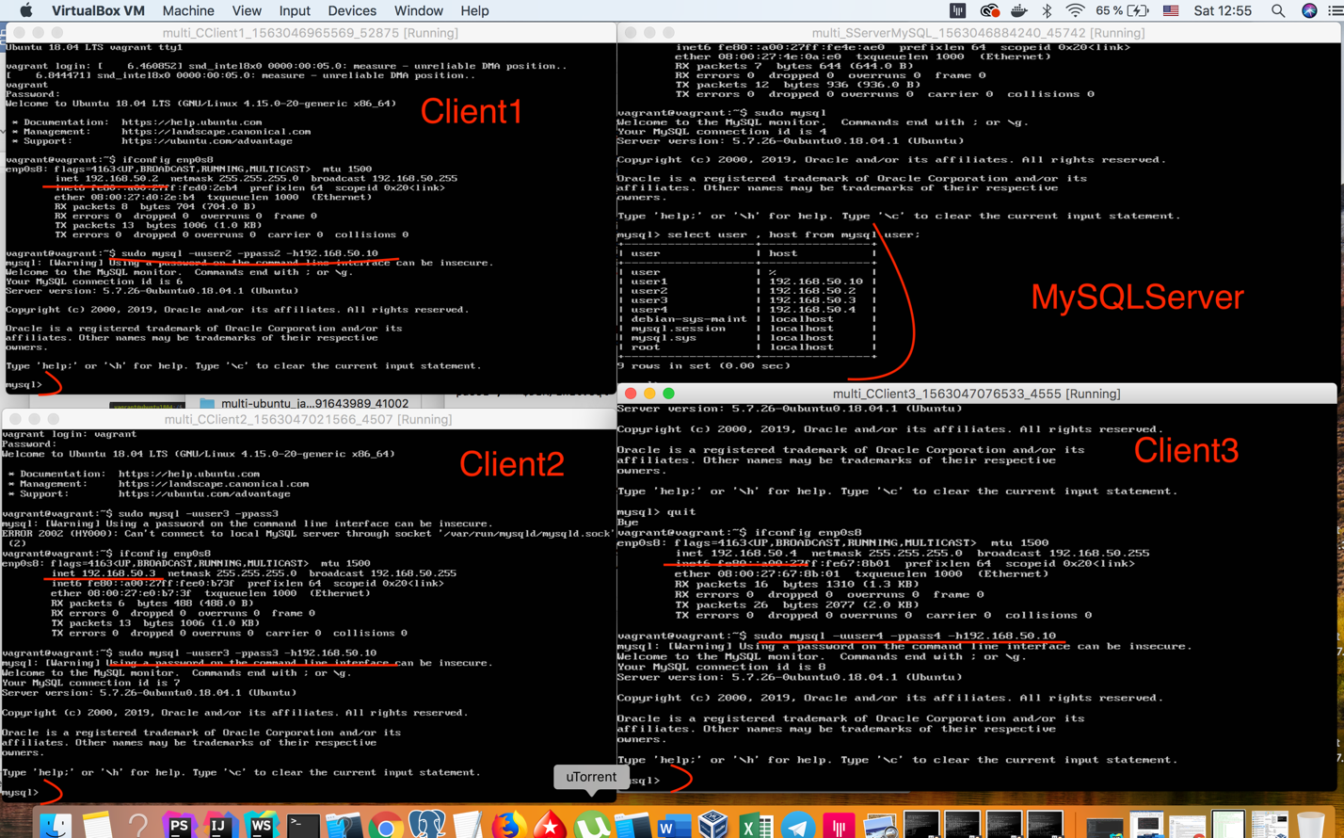

**1.4.4. Using vagrant install the JDK in Windows OS. After installation and configuration, view the java version.**

**1.4.5. Destroy via vagrant VM with Ubuntu**

**1.5. Create your own VagrantBox based on Ubuntu 1804**

**1.5.1. Based on the Ubuntu 1804 image, create a VM in VirtualBox**

Vagrantfile

Vagrant.configure("2") do |config|

config.vm.box = "generic/ubuntu1804"

end

Commands

vagrant init generic/ubuntu1804

vagrant up

**1.5.2. Install OpenJDK and configure on this VM**

sudo apt-get install -y openjdk-8-jre

sudo apt-get install -y openjdk-8-jdk

whereis java

JAVA_HOME=/usr/bin/java

export PATH=$PATH:$JAVA_HOME

Screenshot #3. Java version, $JAVA_HOME , $PATH values

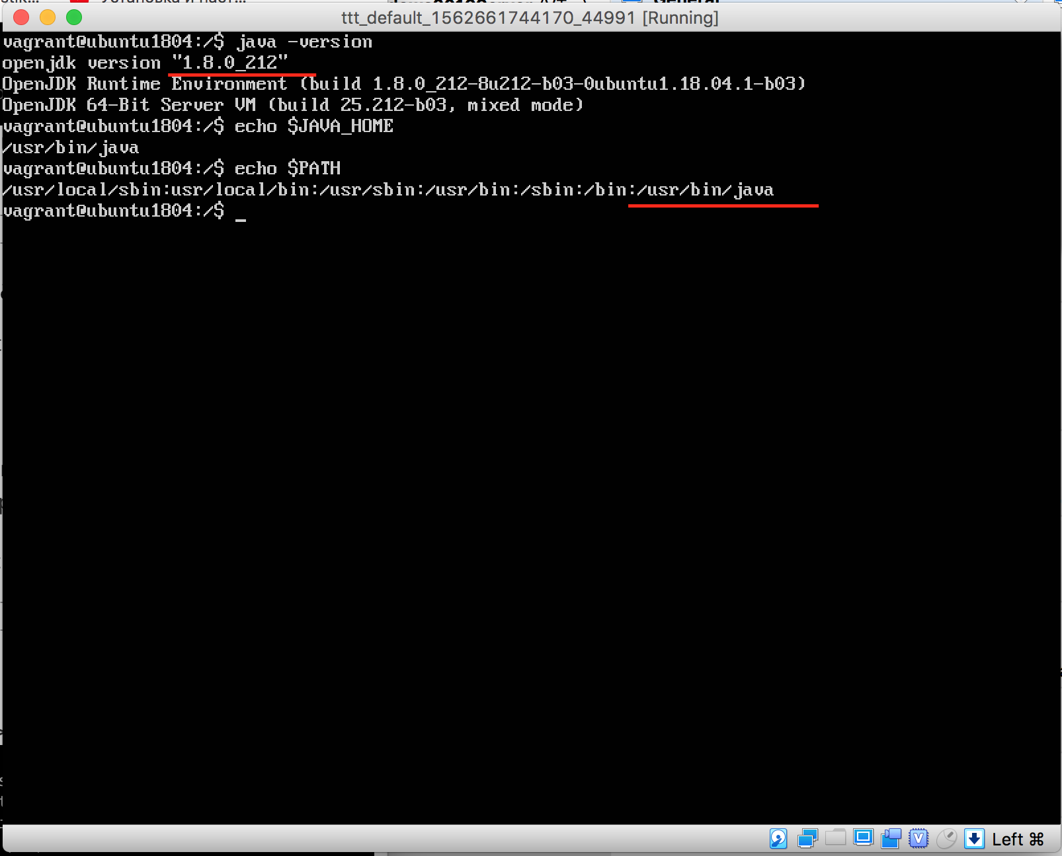

**1.5.3. Install Intellij IDEA on this VM**

sudo snap install intellij-idea-community –-classic

Upgrade Ubuntu to Desktop version (add (GUI)

sudo apt-get install ubuntu-desktop

Screenshot #4. Installed Intellij Idea

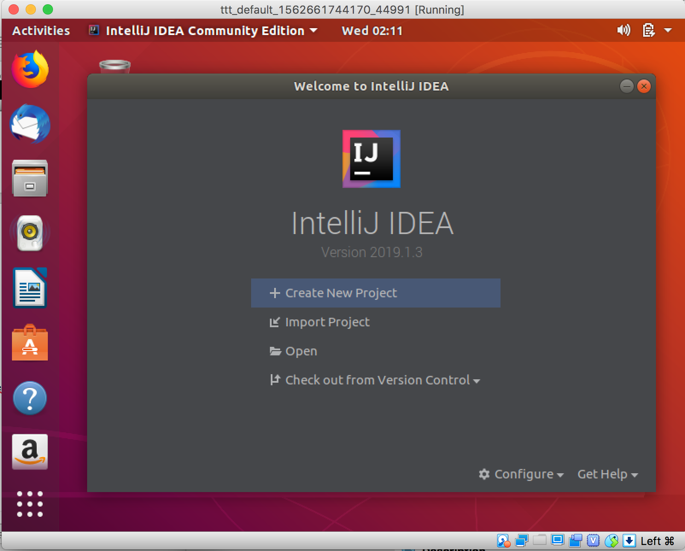

**1.5.4. Install MySQL Client**

sudo apt-get install mysql-client

Screenshot #5. Installed mysql-client

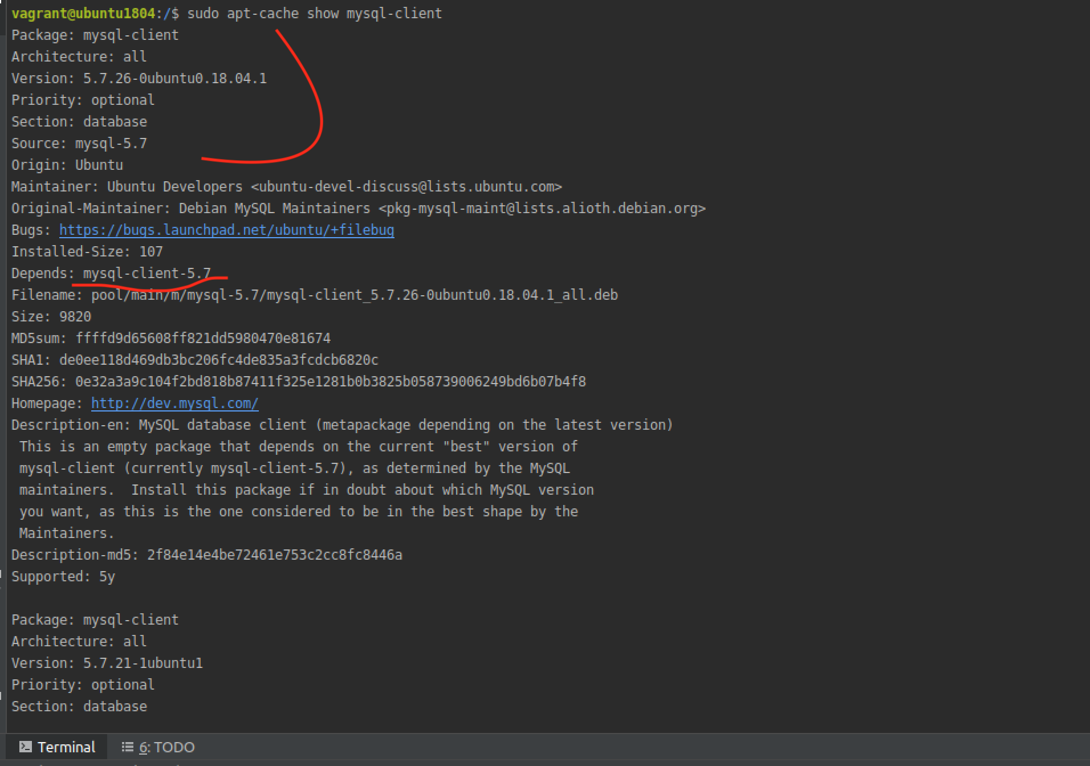

**1.5.5. Make your own VagrantBox**

Follow Oracle documentation for creating base box for Virtulabox provider :

<https://oracle-base.com/articles/vm/create-a-vagrant-base-box-virtualbox>

1.Add Guest addition : it has already added in native box generic/ubuntu1804

2. The "root" user password must be set to "vagrant" and there needs to be a user called "vagrant" with a password of "vagrant".

3.Add insecure public keys

# Add insecure public key.

mkdir /home/vagrant/.ssh

wget -O /home/vagrant/.ssh/authorized_keys https://raw.githubusercontent.com/hashicorp/vagrant/master/keys/vagrant.pub

chown -R vagrant:vagrant /home/vagrant/.ssh

chmod 0700 /home/vagrant/.ssh

chmod 0600 /home/vagrant/.ssh/authorized_keys

3. Network adapter#1 must be NAT. Also remember MAC address:

config.vm.base_mac = "080027AE3BAC"

4.Run command:

Vagrant package –base ubuntu1804

5. Upload file *package.box* to Vagrant cloud <https://app.vagrantup.com/>

Resulting box:

<https://app.vagrantup.com/dennis00010011b/boxes/ubuntu1804-desktop-java-intellij-mysqlclient/versions/0.3>

**1.5.6. Destroy VM Ubuntu 1804**

From Vagrantfile directory:

vagrant halt default // gracefully stop VM (or --force)

vagrant destroy default //remove VM

**1.5.7. From the box was created in section 1.5.5, create Vagrantfile with three machines and configure the local network**

Vagrantfile

Vagrant.configure("2") do |config|

(1..3).each do |i|

config.vm.define "javadev#{i}" do |ubuntu|

#it was used for debugging purpose , to avoid the waisting time for

#uploading/downloading to Vagrant cloud

#ubuntu.vm.box_url = "../ttt/package.box"

ubuntu.vm.box = "dennis00010011b/ubuntu1804-desktop-java-intellij-mysqlclient"

ubuntu.vm.box_version = "0.3"

ubuntu.vm.network "private_network", ip: "192.168.50.#{i+1}"

end

end

end

Screenshot #5. Three VMs from own Vagrant box

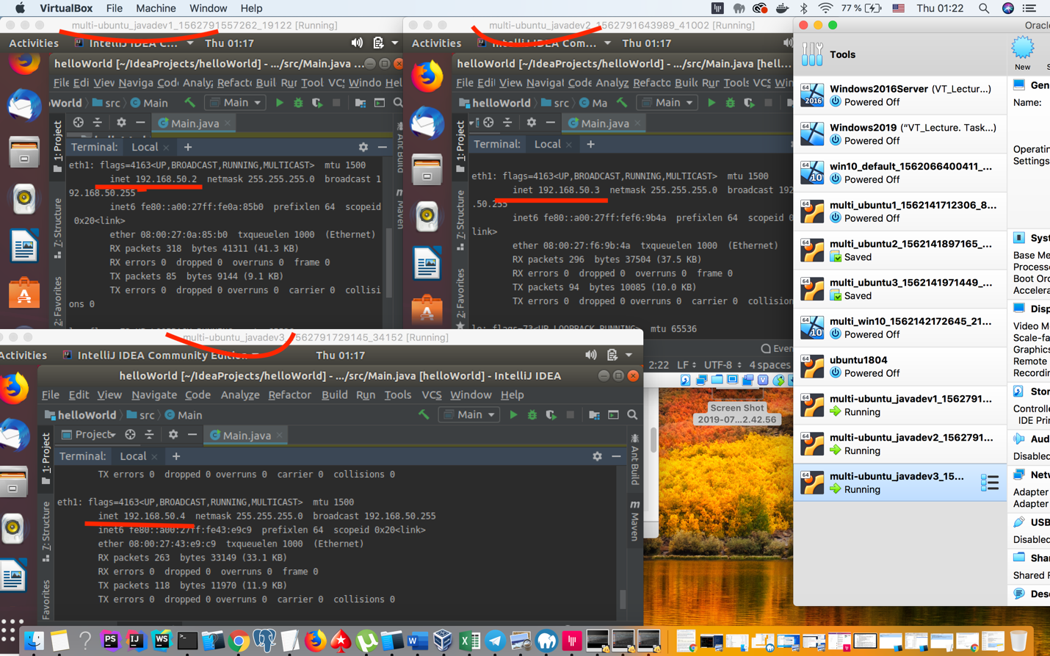

Notice. New created base box should be tested. It can be done by upload and download to Vagrant cloud but it takes a lot of time. Decision could be to boot VMs from local file package.box.

* Add new created package.box to Vagrant

vagrant box add ./package.box --name ubuntu1804-desktop-java-intellij-mysqlclient

* in Vagrantfile specify name box as local path

ubuntu.vm.box = "../ttt/package.box"

* in Vagrantfile comment version

#ubuntu.vm.box_version = "0.3"

**1.5.8. Check LAN connections**

LAN connection was already configurated in Vagrantfile

ubuntu.vm.network "private_network", ip: "192.168.50.#{i+1}"

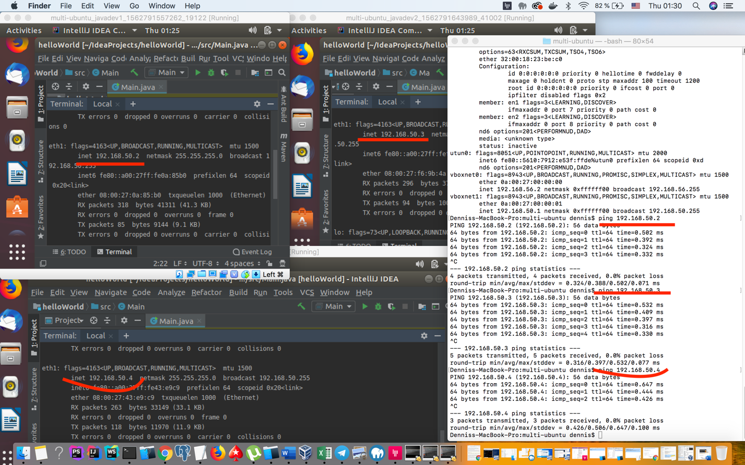

**1.5.9. Check connection to MySQL server**

All VMs are connected to MySQL server 198.162.50.10:

mysql -uuser -ppass -h192.168.50.10

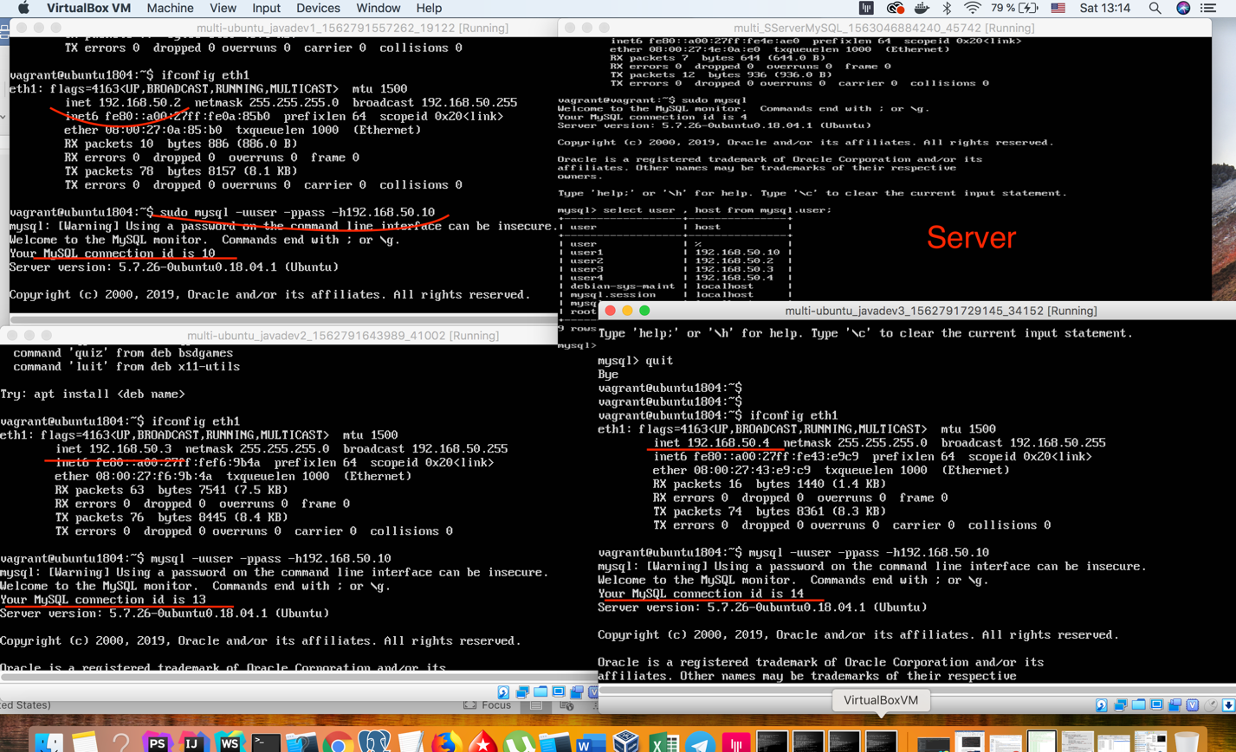

**2. Vagrant vs Hyper-V**

**2.1. Install Hyper-V**

**2.2. Install Vagrant**

**2.3. Create a Vagrantfile based on the box Windows 10**

**2.3.1. Up three Windows 10 with network settings**

Notice: *Sometime vagrant up command doesn’t start with Hyperv boxes for some reason. In this case provider should be specified: vagrant up –provider=hyperv*

Vagrant.configure("2") do |config|  
    (1..3).each do |i|  
        config.vm.define "comp#{i}" do |win|  
           win.vm.box = "gusztavvargadr/windows-10"  
  win.vm.boot_timeout=1800  
           win.vm.network "private_network", type: "dhcp"  
        end   
    end  
end

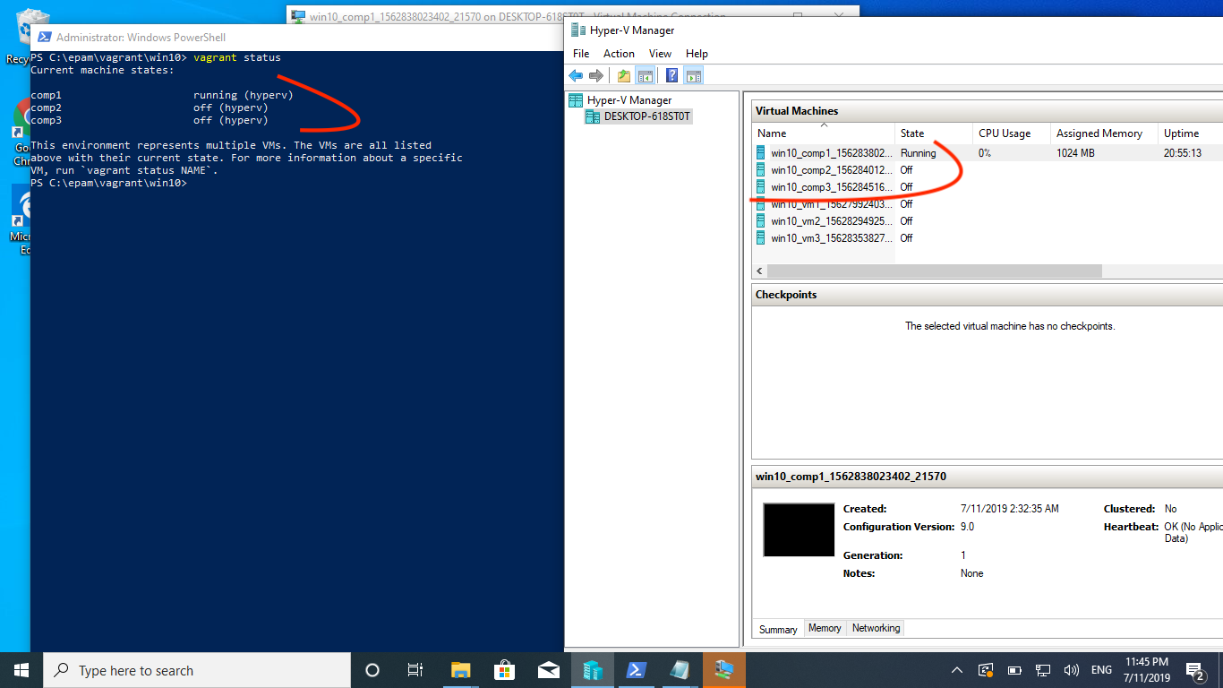

* + 1. **Connect to the box via vagrant ssh**

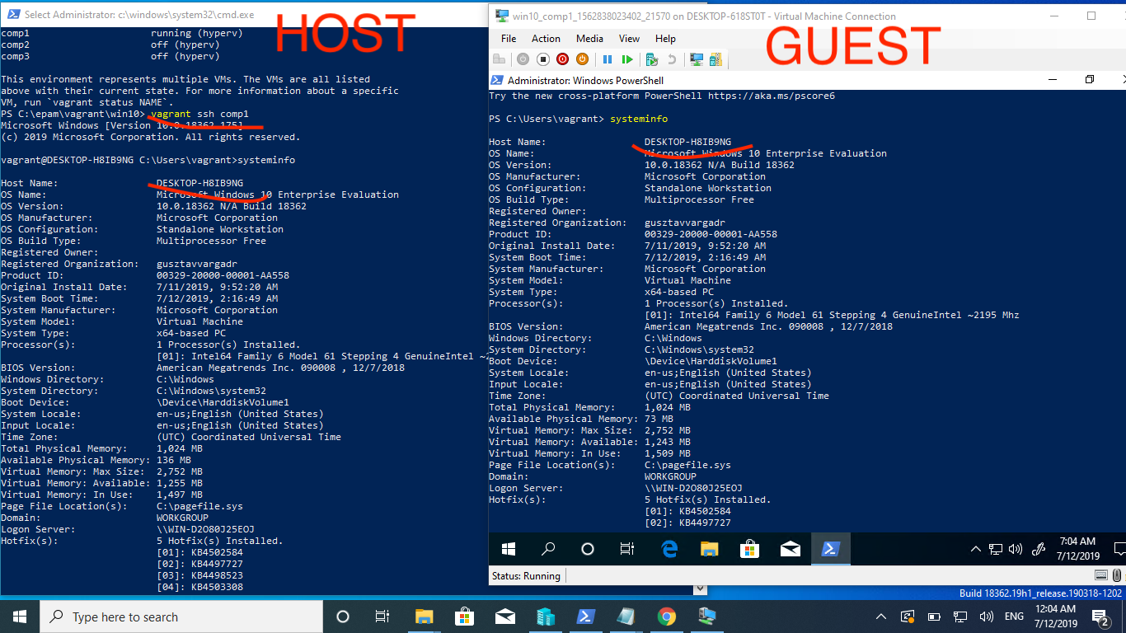

**2.3.3. Change the communicator to "winrm"**

**2.3.4. Connect to box via winrm. Check LAN connections.**

**2.3.5. Destroy box**

**2.4. Create a multi-box configuration with a local network, using for three client VM boxes with Windows 10 OS and for a server VM box with Ubuntu 1804 OS**

**2.4.1. Using provisioning in the Ubuntu OS, install MySQL Server and set up a guest connection to MySQL using different usernames for client machines**

**2.4.2. Using Windows provisioning, install the MySQL client and configure a guest connection to the MySQL server using different usernames for client machines.**

**2.4.3. Up all VM with one vagrant command.**

**2.4.4. Connect via vagrant ssh to server**

**2.4.5. Connect via "winrm" to client machines and check the connection of clients to the MySQL server**

**2.4.6. For all client machines using vagrant, install the JDK.**

**2.4.7. After installation and configuration, view the java version.**

**2.5. Create your own VagrantBox based on Windows 10 OS**

**2.5.1. Add Intellij IDEA to one of the Windows client machines created in section 2.4**

**2.5.2. Based on this VM, make your own VagrantBox**

**2.5.3. Destroy all Windows VMs with vagrant**

**2.5.4. Create a Vagrantfile to install three VMs with a configured LAN based on the OS created in section 2.5.2 and add a connection to the MySQL Server on the VM created in section 2.4.1**

**2.5.5. Up all VMs and check connection to MySQL Server from VMs with Windows OS 3. Create a report with screenshots and attach script files demonstrating the solution of the tasks**